TEMPORAL VARIATIONS IN SUBLIMATION AND THEIR RELATION WITH RIDGE FORMATION IN MARTIAN MID-LATITUDE ICE SCARPS. L. S. Perez-Mancipe¹, A. M. Bramson², K. L. Laferriere³, D. M. H. Baker⁴, ¹Universidad de los Andes, Bogotá, Colombia (ls.perez2@uniandes.edu.co), ²Purdue University, West Lafayette, IN, ³University of Central Florida - Florida Space Institute, Orlando, FL, ⁴NASA Goddard Space Flight Center, Greenbelt, MD.

Introduction: The mid-latitude regions of Mars have abundant evidence for the presence of water in the form of shallowly buried ice deposits. These ice sheets undergo both accumulation and sublimation, two factors which vary over time in response to changes in Mars’ orbital parameters (orbital forcing). Understanding these ice deposits thus provides a window into how the geology and climate of a planet responds to its orbital/axial changes [1].
Ice-exposing scarps were discovered in the northern and southern midlatitudes, revealing the internal structure of thick (~100 m), massive ice deposits which may be part of the latitude-dependent mantle [2]. These scarp sites are characterized by a steep (~45º) pole-facing scarp that is often adjacent to a pit with roughly triangular appearance [2–4], as shown in Figure 1. These scarps are hypothesized to form due to sublimation of the ice sheet initiating at a localized point, after which the scarp retreats equatorward, resulting in a face that is nearly perpendicular to the direction of retreat. Ridge structures within the pit are observed parallel to the present-day scarp, which we hypothesize represent periods of slower sublimation where the scarp position stagnated and accumulated debris at the base, while the intervening depressions or "valleys" correspond to episodes of rapid ice loss and retreat of the scarp position [3].
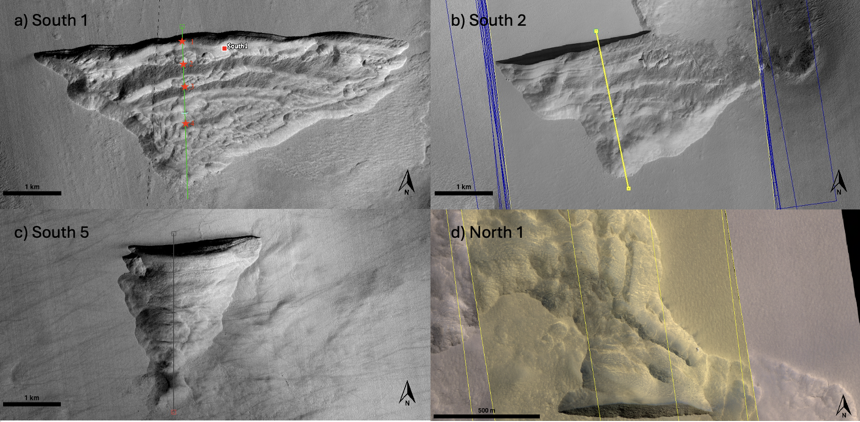
Figure 1: HiRISE images of three icy scarps found in the southern hemisphere (a–c) and one in the norther hemisphere (d). South 1: upper left (a), -56.6°N, 114°E. South 2: upper right (b), -55.1°N, 109.4°E. South 5: lower left (c), -57.2°N, 89.8°E. North 1: lower right (d), 54.1°N 212.1°E.
We aim to test this hypothesis to understand how orbital forcing affects the geomorphology of these icy scarp sites and investigate if variable retreat rates is a plausible explanation for the observed ridges. To address this, we aim to characterize and compare ridge morphologies—such as number and spacing—across scarps in both hemispheres and quantify the relationship between orbitally forced sublimation cycles and ridge formation.
Mapping: Using the catalog of exposed ice sites [4] as a guide, we mapped the scarp sites (8 in the South and 10 in the North) based on the number of ridges and the spacing between them using the software JMARS. We traced elevation profiles perpendicular to the scarp face, allowing us to identify the number of relative topographic highs and measure the average spacing between them. Each scarp was cataloged with its coordinates, ridge count, mean ridge separation, and brief notes on its visual appearance. In cases where Digital Terrain Models (DTMs) were not available, we relied on HiRISE imagery to visually count the number of ridges and separation. While less precise, this approach still provided a general sense of ridge scale, frequency, and clarity.
All collected data were compiled into a table to enable comparison across hemispheres. Particular attention was given to potential morphological differences between Northern and Southern hemisphere scarps, with an emphasis on ridge expression.
Thermal Modeling and Sublimation Calculations: We used a 1D semi-implicit thermal conduction model that simulates the energy balance at the Martian surface and the heat transfer between numerical subsurface layers [5]. The model then calculates stability of the H₂O ice via free and forced convection for exposed ice and diffusive vapor exchange through a surficial lag deposit for subsurface ice. The model was applied to three mid-latitude scarps (South 1, 2 and 5) using present-day topography and extended over the last 20 Mya by incorporating Mars’ time-varying orbital and axial parameters. Thus, the inputs varied according to the latitude, slope and orientation of each icy scarp. Cumulative ice loss is used to quantify horizontal retreat of the scarp, and temporal transitions in sublimation regimes are identified through inflection points in its derivative.
While we initially modeled the retreat of the scarps over 20 Mya, we found that the total sublimation would exceed the observed length of the scarps after just ~0.5 Mya. We thus focus our analysis on this temporal extent. With the topographic profiles of each scarp (taken from HiRISE DTMs), we qualitatively associated the ridges to the periods of slow sublimation.
Results and Discussion: We found that scarps in the southern hemisphere tend to exhibit more ridges than those in the north, with average counts ranging from 3 to 5 in the south, compared to 2 to 3 in the north. Ridges in the south also appear more continuous topographically prominent and tend to run parallel to the largest pole-facing scarp face (Figures 1a-c). In contrast, northern scarps frequently display diffuse ridge patterns, and in some cases—such as North 1 (Figure 1d), North 3, and North 8—ridges appear perpendicular to the scarp. This suggests that their origin may differ and may not be solely attributed to scarp retreat.
From our thermal models (Figures 2-4) and the 2.5-3 km length of the pits (which we assume is the distance of retreat from the initiation point to present-day scarp), we find that these features have only been retreating for the past 0.5 Mya. This age is younger than the 2.4 Mya age suggested by previous studies [3] that assume a constant retreat rate over time. Additionally, this suggests that the variations in eccentricity and longitude of perihelion have a more dominant effect on the stability of these features than just the variation in obliquity, and may contribute to the formation of the ridges found in the scarp sites. All three southern scarp sites (South 1, 2 and 5) are found to exhibit similar geomorphologies and behaviors, with scarp initiation at ~0.5 Mya.
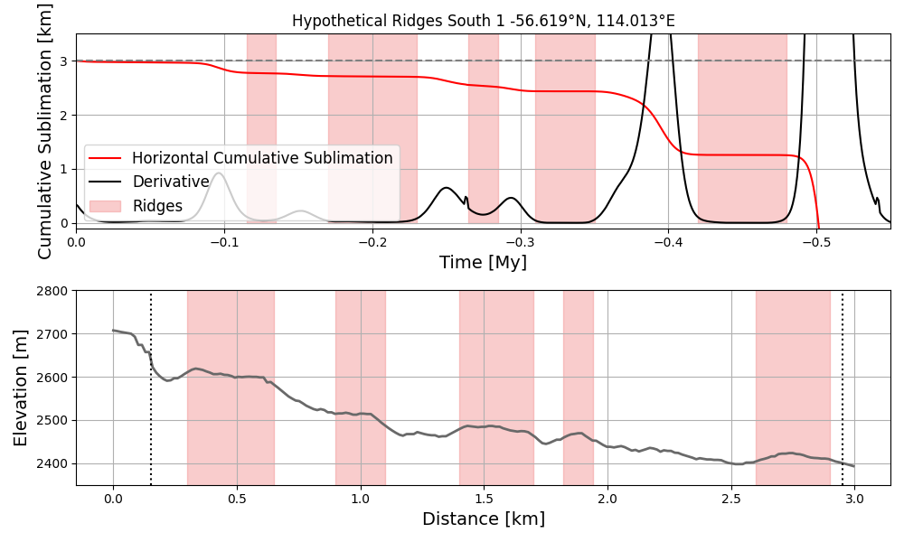
Figure 2: South 1 comparison between the horizontal cumulative sublimation plot (upper plot) along the extension of the scarp site that shows its derivative and periods of low sublimation highlighted in red, with the topographic profile (lower plot) with visible ridges highlighted in red.
Figures 2, 3 and 4 show the horizontal cumulative sublimation plots over the past half million years with the periods of low sublimation highlighted in red and their topographic profiles shown in the panels below, with the locations where we interpret ridges also highlighted. We hypothesize that at these times of ice stability (low/no sublimation), the scarp would stabilize in place and develop ridges at the base of the cliff. From our mapping, we observed that Scarps 1 and 2 have five ridges, which aligns with the number of inflection points suggested from the sublimation model, supporting this hypothesis. If our interpretation of ridges corresponding to periods of low sublimation is correct, our results therefore could allow us to place ages on the individual ridges. However, we note that some ridges in the other scarp sites are more diffuse and some of them are not consistent horizontally along the site, which may be related to additional processes not considered by our sublimation-based model. This could include heterogeneities within the ice deposit which could cause differential retreat rates that would not be purely driven by orbital forcing-induced climate changes.

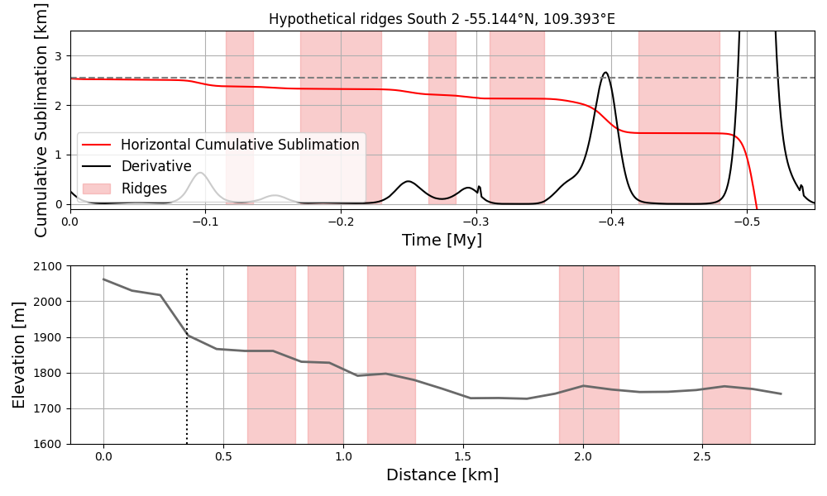
Figure 3: South 2 comparison between the horizontal cumulative sublimation plot (upper plot) along the extension of the scarp site that shows its derivative and periods of low sublimation highlighted in red, with the topographic profile (lower plot) with visible ridges highlighted in red.
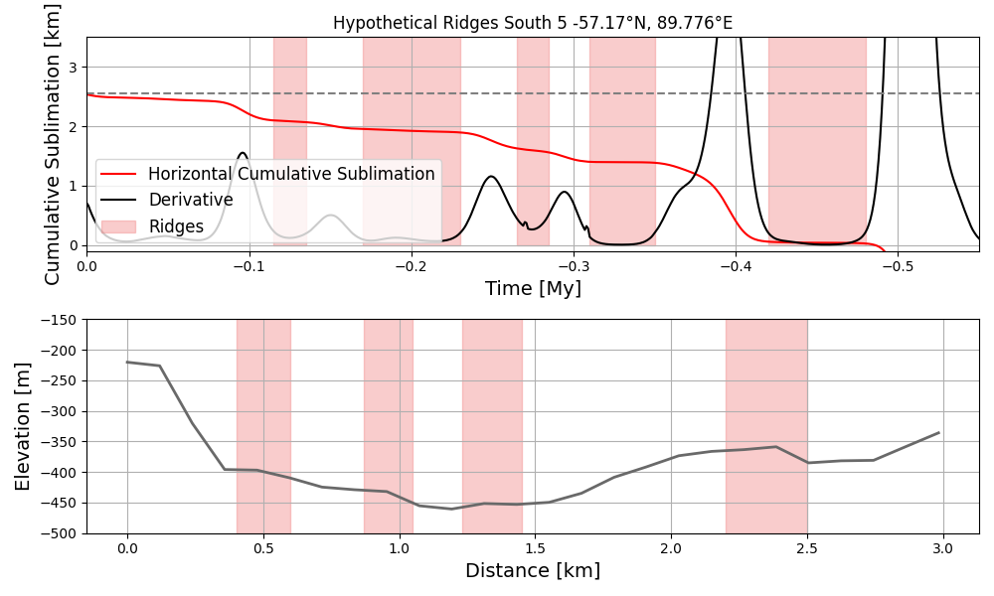
Figure 4: South 5 comparison between the horizontal cumulative sublimation plot (upper plot) along the extension of the scarp site that shows its derivative and periods of low sublimation highlighted in red, with the topographic profile (lower plot) with visible ridges highlighted in red.
References: [1] Head, J. W. et al. (2003). Nature, 426(6968):797–802. [2] Dundas, C. M. et al. (2018). Science, 359(6372):199–201. [3] Williams, K. et al. (2022). Icarus, 386:115174. [4] Dundas, C. M. et al. (2021). Journal of Geophysical Research: Planets, 126(3):e2020JE006617. [5] Bramson, A. M. et al. (2017). Journal of Geophysical Research: Planets, 122(11), 2250-2266.

